Assessment 3 - Group Project Report – Project Brief

Due Date: 15 October 2026, 14:00 ACST (Darwin local time)
Weighting: 50%
Group Size: 4 students (the same group as in Assessments 2)

This assessment must be completed within your existing group. Individual work submissions will not be accepted.

Objective 2
Your team will perform two related, but distinct linear regression tasks as specified below.

Linear Regression 2.1
- Build and evaluate a linear regression model that predicts the goal difference between two opposing teams in FIFA World Cup 2026 matches.
- You must compile a dataset that comprises 104 rows, each representing an actual match in the FIFA World Cup 2026.
- Your dataset must include exactly eight (8) explanatory variables (excluding any ID field).
- You must thoughtfully decide what these explanatory variables would be and then collect their corresponding data.

Note: All explanatory variables must provide information that is available before a match. For example, the number of shots on target made during a match cannot be used as an explanatory variable for predicting the goal difference of that match.

Linear Regression 2.2
- Build and evaluate a second linear regression model that predicts the number of goals scored by a team in a single FIFA World Cup 2026 match.
- You must compile a dataset that comprises 208 rows, each representing a team's statistics for a specific match.
- Your dataset must include exactly eight (8) explanatory variables (excluding any ID field).
- You must thoughtfully decide what these explanatory variables would be and then collect their corresponding data.

Note: All explanatory variables must provide information that is available before a match. For example, the number of shots on target made by a team during a match cannot be used as an explanatory variable for predicting their goal for that match.

All your data analyses and visualisations must be done in Python. Microsoft Excel can be used but only for preparing your raw datasets. Data wrangling and all other analyses must be done with Python.

Grading
Please see the grading rubric for detailed marking criteria. Your instructor reserves the right to further differentiate individual grades where necessary, as explained in the section "Individual Marks" below.

Deliverables
Submit your work no later than the stated due date of this assignment to avoid late submission penalties. Please submit:

A written group report:
One group report per team.

The report must be in a single Microsoft Word file (.docx) and not exceed 4 pages (A4, single-spaced, single column, 11pt font), including the title, your names and student IDs.

Table of contents, list of figures, and list of references are not needed as they will not contribute any mark.

There is no minimum length to the report. Do not submit multiple files.

Access to Python code:
1 URL to a OneDrive / GitHub / BitBucket repository containing all Python files and the dataset used for this assessment

Turnitin originality report:
A copy of Turnitin originality report. Use the provided Turnitin link to perform the originality check and obtain the originality report.

AI usage declaration form:
A copy of the signed AI Usage Declaration Form:
- Include a clear acknowledgement of the use of generative AI.
- A reflective account of the use of generative AI in the project, accompanied by a URL to AI conversation history where applicable.
- Please use the following template:

Other relevant supporting materials (optional):
You may submit any supplementary items to further address the marking rubric requirement.

Submission Guidelines

Please submit one (1) .zip file containing:
- A group report in Microsoft Word format (.docx)
- A text file (.txt) containing a link to Python codes on OneDrive, GitHub or BitBucket.
- A copy of Turnitin originality report.
- A copy of AI Usage Declaration Form signed by all team members.

Submit your .zip file via Learnline no later than the stated due date of this assignment.
- Email submissions will not be accepted.
- Do not submit multiple documents. Only one submission is required per team.
- Late submission penalty may apply in accordance with CDU policy.

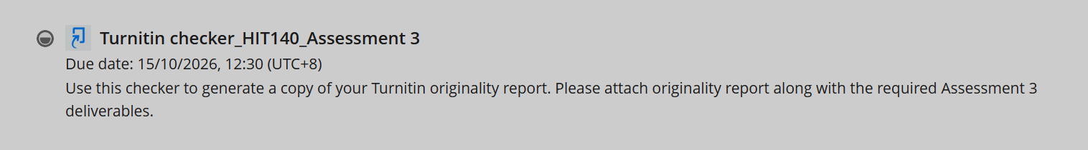

Rubric
